Radius of a Cylinder
# Source: AI Source: Provided by: [Data Path: Persons Table -> ID Column: 1, Name_En Column: Motasem Essam] -> From: [ChatGPT] on [7/25/2026]
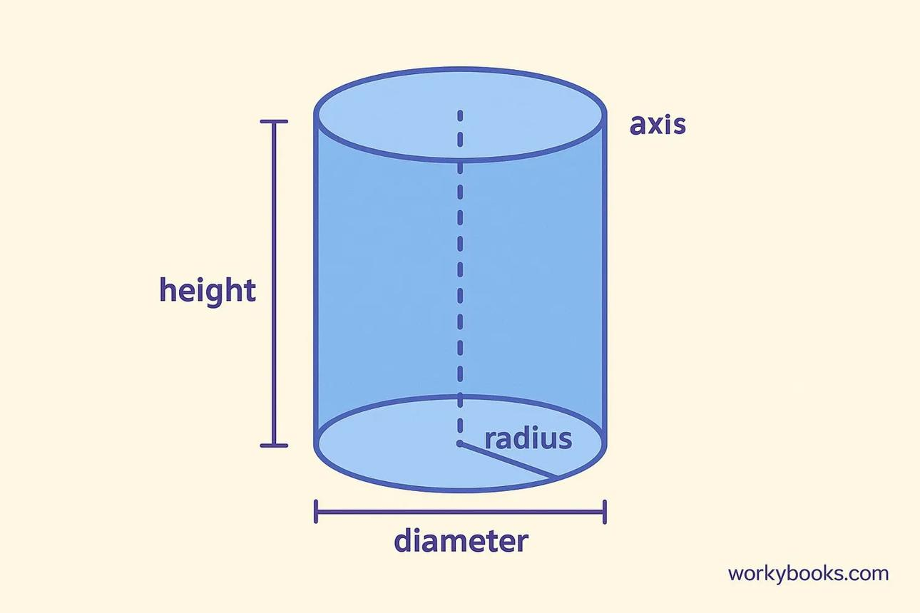
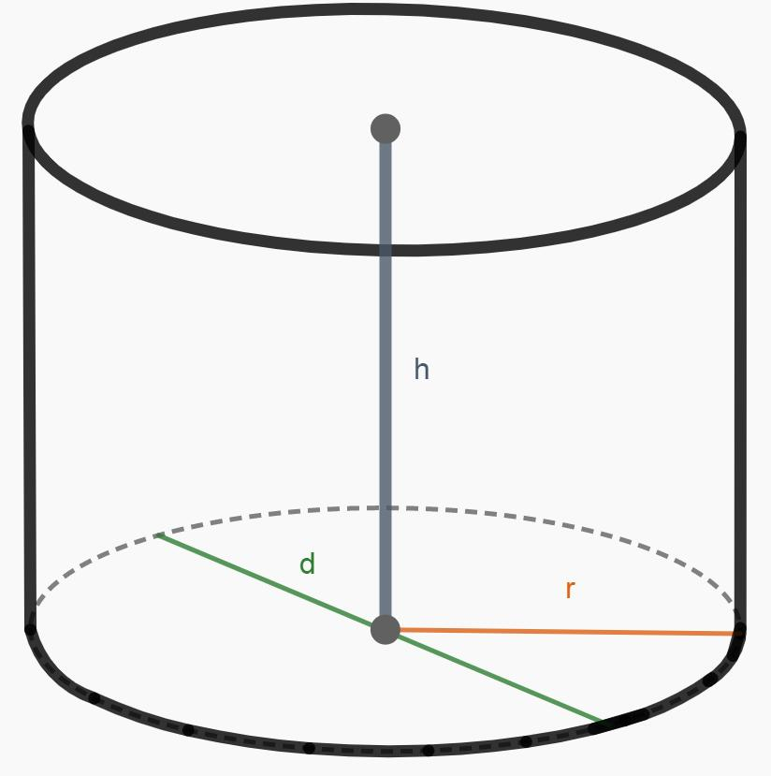
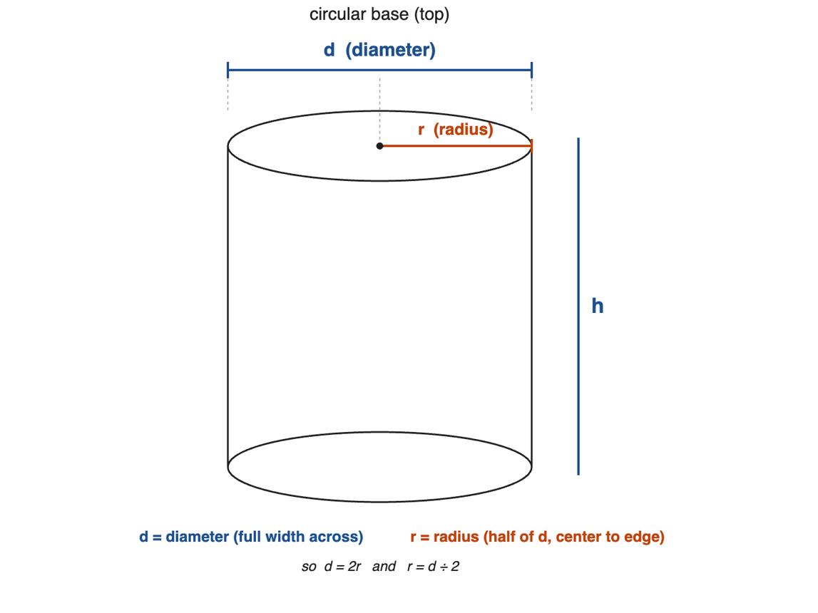

Definition
# Source: AI Source: Provided by: [Data Path: Persons Table -> ID Column: 1, Name_En Column: Motasem Essam] -> From: [ChatGPT] on [7/25/2026]
The radius of a cylinder is the distance from the center of a circular base to any point on its circular boundary. A circular cylinder has two congruent circular bases, so both bases have the same radius.
The radius is a linear measurement that determines the size of the circular bases and contributes to the cylinder's surface area and volume.

Simple Definition
# Source: AI Source: Provided by: [Data Path: Persons Table -> ID Column: 1, Name_En Column: Motasem Essam] -> From: [ChatGPT] on [7/25/2026]
The radius is the distance from the center of the cylinder's circular base to its edge.
It is half the diameter of the base.
$$\boxed{r=\frac{d}{2}}$$

Geometric Representation and Components
# Source: AI Source: Provided by: [Data Path: Persons Table -> ID Column: 1, Name_En Column: Motasem Essam] -> From: [ChatGPT] on [7/25/2026]
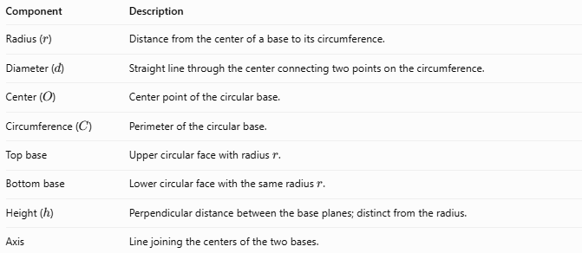
Component | Description
Radius ($r$) | Distance from the center of a base to its circumference.
Diameter ($d$) | Straight line through the center connecting two points on the circumference.
Center ($O$) | Center point of the circular base.
Circumference ($C$) | Perimeter of the circular base.
Top base | Upper circular face with radius $r$.
Bottom base | Lower circular face with the same radius $r$.
Height ($h$) | Perpendicular distance between the base planes; distinct from the radius.
Axis | Line joining the centers of the two bases.

Types and Classification
For an ordinary circular cylinder, the radius describes the size of each circular base.

Base Radius
# Source: AI Source: Provided by: [Data Path: Persons Table -> ID Column: 1, Name_En Column: Motasem Essam] -> From: [ChatGPT] on [7/25/2026]
The radius measured on either circular base. In a cylinder with congruent bases, the top and bottom radii are equal.
$$r_{\text{top}}=r_{\text{bottom}}=r$$

Outer Radius
# Source: AI Source: Provided by: [Data Path: Persons Table -> ID Column: 1, Name_En Column: Motasem Essam] -> From: [ChatGPT] on [7/25/2026]
For a hollow cylinder or cylindrical pipe, the outer radius is the distance from the center to the outer circular boundary.

Inner Radius
# Source: AI Source: Provided by: [Data Path: Persons Table -> ID Column: 1, Name_En Column: Motasem Essam] -> From: [ChatGPT] on [7/25/2026]
For a hollow cylinder, the inner radius is the distance from the center to the inner circular boundary.

Radius of a Hollow Cylinder
# Source: AI Source: Provided by: [Data Path: Persons Table -> ID Column: 1, Name_En Column: Motasem Essam] -> From: [ChatGPT] on [7/25/2026]
A hollow cylinder has two distinct radii:
- $R$ = outer radius
- $r$ = inner radius
Its wall thickness is:
$$\boxed{t=R-r}$$
These inner and outer radii are relevant to pipes, tubes, and hollow cylindrical structures.

Mathematical Formulas

Radius and Diameter
# Source: AI Source: Provided by: [Data Path: Persons Table -> ID Column: 1, Name_En Column: Motasem Essam] -> From: [ChatGPT] on [7/25/2026]
The diameter is twice the radius:
$$\boxed{d=2r}$$
The radius is half the diameter:
$$\boxed{r=\frac{d}{2}}$$

Radius from the Circumference
# Source: AI Source: Provided by: [Data Path: Persons Table -> ID Column: 1, Name_En Column: Motasem Essam] -> From: [ChatGPT] on [7/25/2026]
The circumference of a circular base is:
$$C=2πr$$
Rearranging gives:
$$\boxed{r=\frac{C}{2π}}$$
Alternatively, using $C=πd$:
$$r=\frac{C}{2π}$$

Radius from the Base Area
# Source: AI Source: Provided by: [Data Path: Persons Table -> ID Column: 1, Name_En Column: Motasem Essam] -> From: [ChatGPT] on [7/25/2026]
The area of a circular base is:
$$A_{B}=πr^{2}$$
Therefore:
$$\boxed{r=\sqrt{\frac{A_{B}}{π}}}$$

Radius from the Cylinder's Volume
# Source: AI Source: Provided by: [Data Path: Persons Table -> ID Column: 1, Name_En Column: Motasem Essam] -> From: [ChatGPT] on [7/25/2026]
The volume of a circular cylinder is:
$$V=πr^{2}h$$
Rearranging for the radius:
$$\boxed{r=\sqrt{\frac{V}{πh}}}$$

5.5 Radius from the Lateral Surface Area
# Source: AI Source: Provided by: [Data Path: Persons Table -> ID Column: 1, Name_En Column: Motasem Essam] -> From: [ChatGPT] on [7/25/2026]
For a right circular cylinder:
$$A_{L}=2πrh$$
Therefore:
$$\boxed{r=\frac{A_{L}}{2πh}}$$

Radius from the Total Surface Area
# Source: AI Source: Provided by: [Data Path: Persons Table -> ID Column: 1, Name_En Column: Motasem Essam] -> From: [ChatGPT] on [7/25/2026]
For a closed right circular cylinder:
$$A_{T}=2πr^{2}+2πrh$$
Solving for the positive radius gives:
$$\boxed{r=\frac{-h+\sqrt{h^{2}+\frac{2A_{T}}{π}}}{2}}$$
This formula assumes both circular bases and the curved lateral surface are included.

Worked Examples
# Source: AI Source: Provided by: [Data Path: Persons Table -> ID Column: 1, Name_En Column: Motasem Essam] -> From: [ChatGPT] on [7/25/2026]
Example 1 — Find the Radius from the Diameter
A cylinder has a base diameter of $14\text{ cm}$. Find its radius.
Solution:
$$r=\frac{d}{2}$$
$$r=\frac{14}{2}$$
$$\boxed{r=7\text{ cm}}$$
Example 2 — Find the Radius from the Circumference
The circumference of a cylinder's circular base is $20π\text{ cm}$. Find the radius.
Solution:
$$r=\frac{C}{2π}$$
$$r=\frac{20π}{2π}$$
$$\boxed{r=10\text{ cm}}$$
Example 3 — Find the Radius from the Base Area
The area of a cylinder's circular base is $81π{\text{ cm}}^{2}$. Find its radius.
Solution:
$$r=\sqrt{\frac{A_{B}}{π}}$$
$$r=\sqrt{\frac{81π}{π}}=\sqrt{81}$$
$$\boxed{r=9\text{ cm}}$$
Example 4 — Find the Radius from the Volume
A cylinder has a volume of $200π{\text{ cm}}^{3}$ and a height of $8\text{ cm}$. Find its radius.
Solution:
$$r=\sqrt{\frac{V}{πh}}$$
$$r=\sqrt{\frac{200π}{8π}}=\sqrt{25}$$
$$\boxed{r=5\text{ cm}}$$
Example 5 — Find the Radius of a Hollow Cylinder
A hollow cylindrical pipe has an outer radius of $8\text{ cm}$ and an inner radius of $5\text{ cm}$. Find its wall thickness.
Solution:
$$t=R-r$$
$$t=8-5$$
$$\boxed{t=3\text{ cm}}$$

How the Radius Affects a Cylinder
# Source: AI Source: Provided by: [Data Path: Persons Table -> ID Column: 1, Name_En Column: Motasem Essam] -> From: [ChatGPT] on [7/25/2026]
For a right circular cylinder with a fixed height $h$:
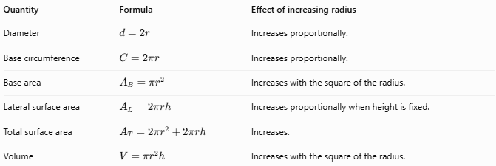
Quantity | Formula | Effect of increasing radius
Diameter | $$d=2r$$ | Increases proportionally.
Base circumference | $$C=2πr$$ | Increases proportionally.
Base area | $$A_{B}=πr^{2}$$ | Increases with the square of the radius.
Lateral surface area | $$A_{L}=2πrh$$ | Increases proportionally when height is fixed.
Total surface area | $$A_{T}=2πr^{2}+2πrh$$ | Increases.
Volume | $$V=πr^{2}h$$ | Increases with the square of the radius.
For example, if the radius doubles while the height stays constant:
- The diameter doubles.
- The circumference doubles.
- The base area becomes four times larger.
- The volume becomes four times larger.
- The lateral surface area doubles.

Radius Compared with Related Measurements
# Source: AI Source: Provided by: [Data Path: Persons Table -> ID Column: 1, Name_En Column: Motasem Essam] -> From: [ChatGPT] on [7/25/2026]
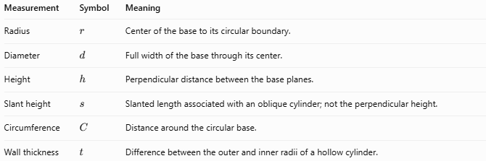
Measurement | Symbol | Meaning
Radius | $$r$$ | Center of the base to its circular boundary.
Diameter | $$d$$ | Full width of the base through its center.
Height | $$h$$ | Perpendicular distance between the base planes.
Slant height | $$s$$ | Slanted length associated with an oblique cylinder; not the perpendicular height.
Circumference | $$C$$ | Distance around the circular base.
Wall thickness | $$t$$ | Difference between the outer and inner radii of a hollow cylinder.
Important distinction: The radius is measured across the circular base, while the height is measured between the two base planes. They represent different dimensions.

Applications
# Source: AI Source: Provided by: [Data Path: Persons Table -> ID Column: 1, Name_En Column: Motasem Essam] -> From: [ChatGPT] on [7/25/2026]
The radius of a cylinder is useful in many practical situations:
- Pipes and tubes: determining internal capacity and wall thickness.
- Cans and containers: calculating base area and storage volume.
- Water tanks: determining capacity from radius and height.
- Engineering: specifying cylindrical shafts, rollers, and machine parts.
- Construction: calculating dimensions of columns and cylindrical foundations.
- Packaging: estimating material requirements for cylindrical objects.

Key Points
# Source: AI Source: Provided by: [Data Path: Persons Table -> ID Column: 1, Name_En Column: Motasem Essam] -> From: [ChatGPT] on [7/25/2026]
- The radius is the distance from the center of a circular base to its boundary.
- A circular cylinder has equal base radii when its bases are congruent.
- The radius is half the diameter: $r=d/2$.
- The radius can be calculated from the circumference, base area, lateral surface area, or volume when the necessary measurements are known.
- Radius is measured in linear units, such as centimetres or metres.
- Areas use square units, and volume uses cubic units.
- A hollow cylinder has separate inner and outer radii.

Conclusion
# Source: AI Source: Provided by: [Data Path: Persons Table -> ID Column: 1, Name_En Column: Motasem Essam] -> From: [ChatGPT] on [7/25/2026]
The radius of a cylinder is a fundamental measurement that determines the size of its circular bases. It is essential for calculating the cylinder's circumference, surface areas, and volume.
The most important relationship is:
$$\boxed{d=2r}$$
For a cylinder with a known volume and height, its radius can also be calculated using:
$$\boxed{r=\sqrt{\frac{V}{πh}}}$$

